**B.M.S College of Engineering**

**P.O. Box No.: 1908 Bull Temple Road,**

**Bangalore-560 019**

**Department of INFORMATION Science & Engineering**



**Course –Mobile Application Development**

**Course Code – 16IS7DCMAD**

**PROJECT REPORT**

**BMSCE HOSTEL APPLICATION**

Submitted to – **SINDHU K**

Submitted by -

**Supreeta Anand Byatnal Tejaswini T N**

**( 1BM16IS090 ) ( 1BM16IS091)**

**INDEX**

1. INTRODUCTION...…………………………………………………3
2. PROBLEM STATEMENT…………………………………………..4
3. DESIGN DIAGRAMS……………………………………………….5
4. IMPLEMENTATION& SNAPSHOTS…………….........................7
5. CONCLUSION……………………………………………………..23
6. REFERENCES.……………………………………………………..23

**INTRODUCTION**

For the past few years the number of educational institutions are increasing rapidly. Thereby the number of hostels are also increasing. Hostels facilitate people coming from cities hundreds of kms so that the accommodation becomes the least of the students’ and the parents’ concerns.

Our android application will help ease the process of researching about BMSCE Hostels as it brings all the necessary information in a single place. This way, the parents and students have a go-to app for any queries about BMSETH hostels.

This project deals with the problems that occur when handled manually. It requires extreme effort in terms of man power and resources to have a person manually answer the questions that a person might have about the hostels. Hence having all these necessary information just a click away on mobile phones will save up a lot of time and energy.

It was seen that three out of four active smart phones in use in November 2017 were android devices according to a survey. Hence this android application can reach the majority of the Smartphone users.

**PROBLEM STATEMENT**

This system is designed in favour of the hostel management. We have got 11 hostels in our college, which consists of 5 girl’s and 6 boy’s hostel. All these hostels at present are managed manually by hostel office. So if any students need any information regarding the hostel they have to contact hostel office for that.

The app should allow students to register first and then with the help of user name and password student can login any time. The app should contain a home page which should have basic information regarding hostel.

The app should have various menu options to see hostel photos, hostel details, hostel warden details, hostel menu and hostel rules and regulations.

The hostel photo options should display various hostel room photos, hostel outdoor photos, hostel sports room photos and along with that hostel mess photos. The hostel details option should display details about various hostels and their location in the campus.

It’s very important to manage the hostel mess menu. The students along with mess wardens can do the menu for certain period of time. The app should allow hosteller to see the menu of breakfast, lunch snacks and dinner of all days.

Each hostel has a warden to manage the hostel. The app should display the warden’s details and students can contact warden through email, call or message. Student can also download the document of hostels rules and regulations.

The students also have the option to contact the hostel office through email., and can ask any queries or ask any details to regarding the app. Student can also share the app using message or instagram.

**DESIGN DIAGRAMS**

1. Login Activity

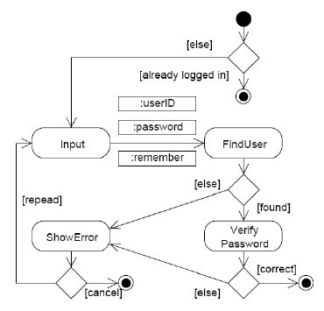

1. BMSCE Hostel Application

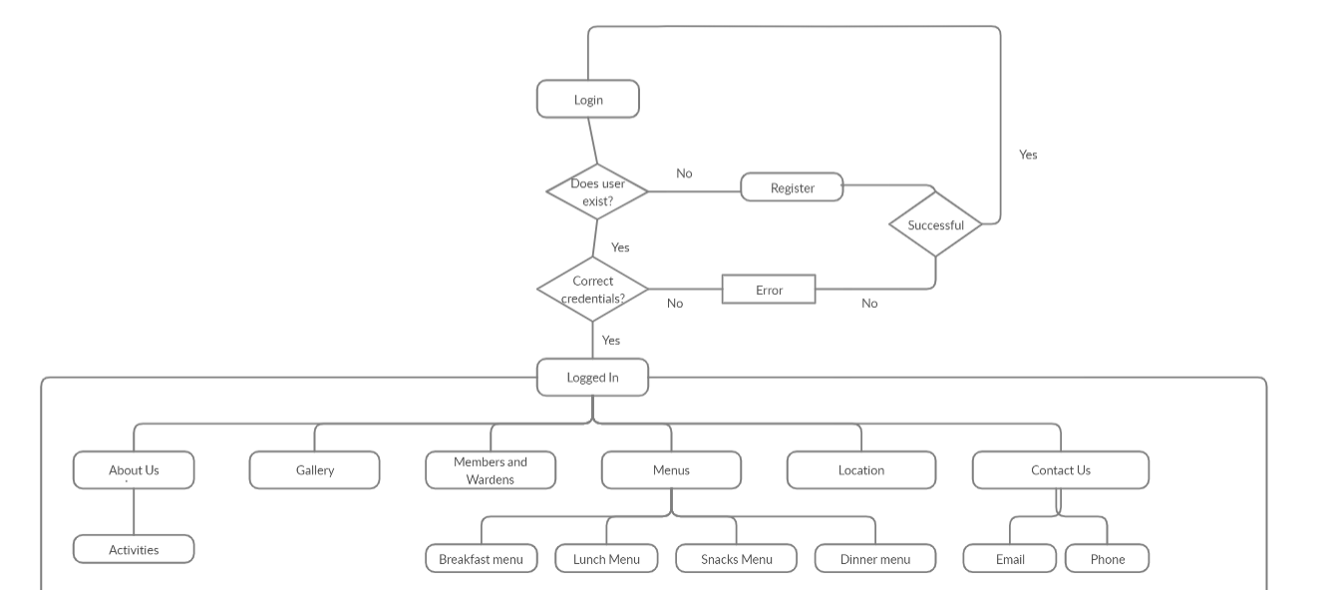

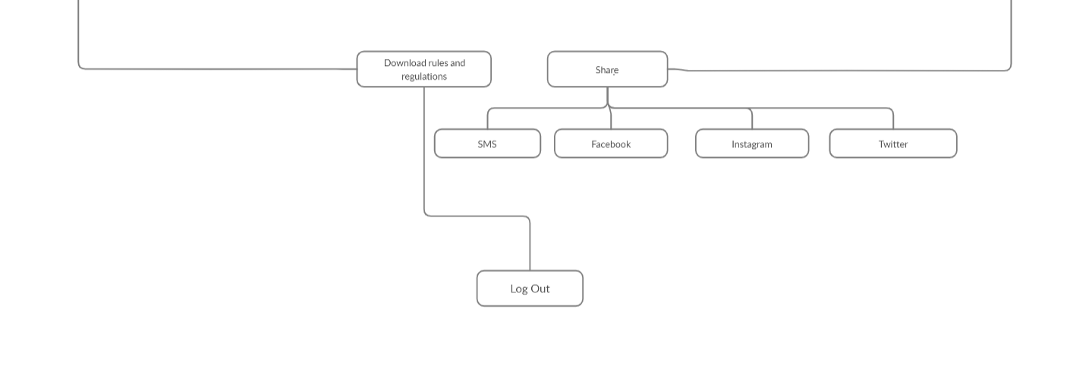

**IMPLEMENTATION& SNAPSHOTS**

**App Starting page**

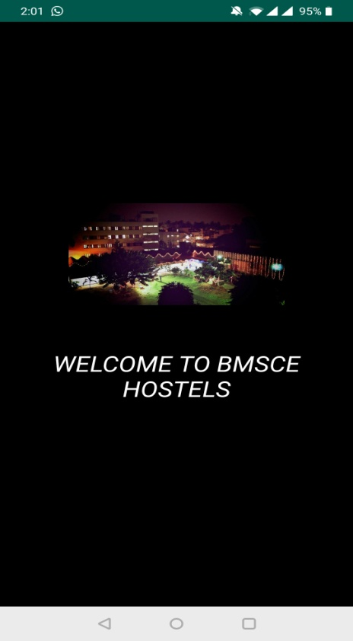

When you open the app this is the first activity that will display. And this is a splash screen.

**Student Registration**

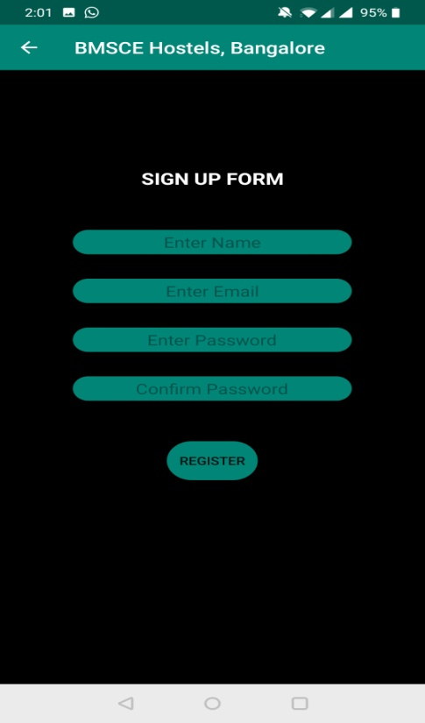

Student can register in the app using register form. This form contains details like name, email and password. The form is connected to a SQLite database. A signup activity with various form items is used.

**Student Login**

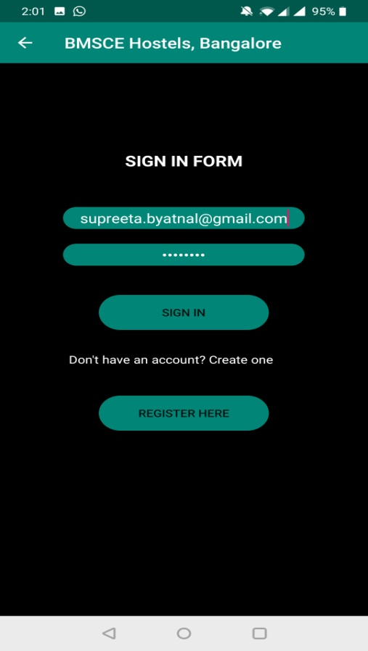

Once the student is registered they can login using their registered email id and password. The data should match whatever their in the database then only they can login otherwise login will be failed. A login activity with various form items are used

**Home Page**

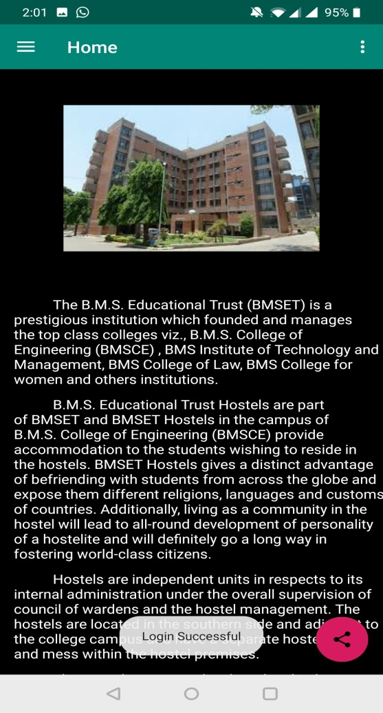

Once the login is successful this is the home fragment which will display. In the home page few basic and important details about college and hostel is displayed along with the hostel photo.

**Menu options**

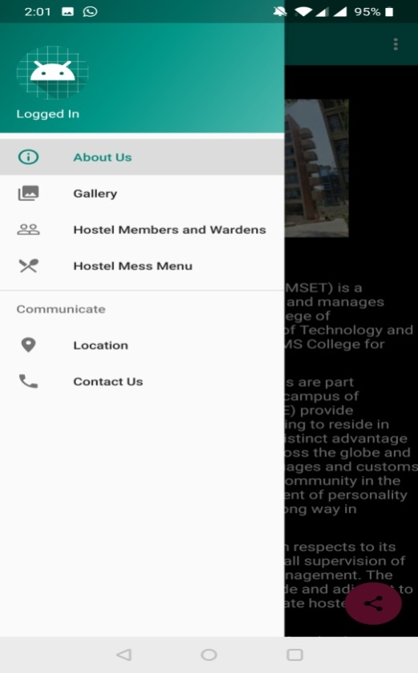

A drawer layout is used for the menu options. This layout has various menu options for gallery, hostel members and wardens and along with hostel mess menu. And also options for location and contact us with hep of it they can contact the hostel office for any doubt and clarification. When we need to use menus like this in the app in that case drawer layout is suitable.

**Gallery**

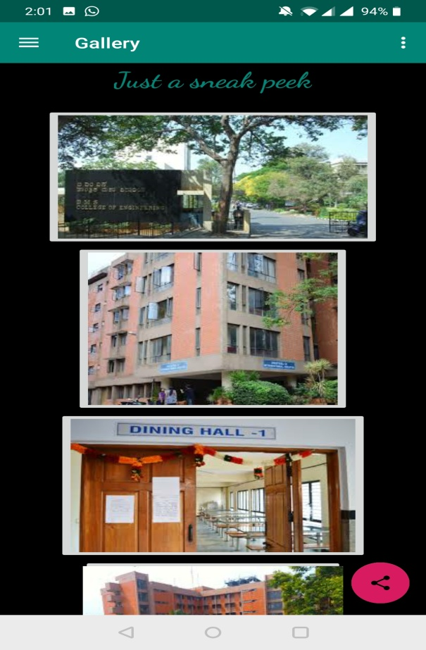 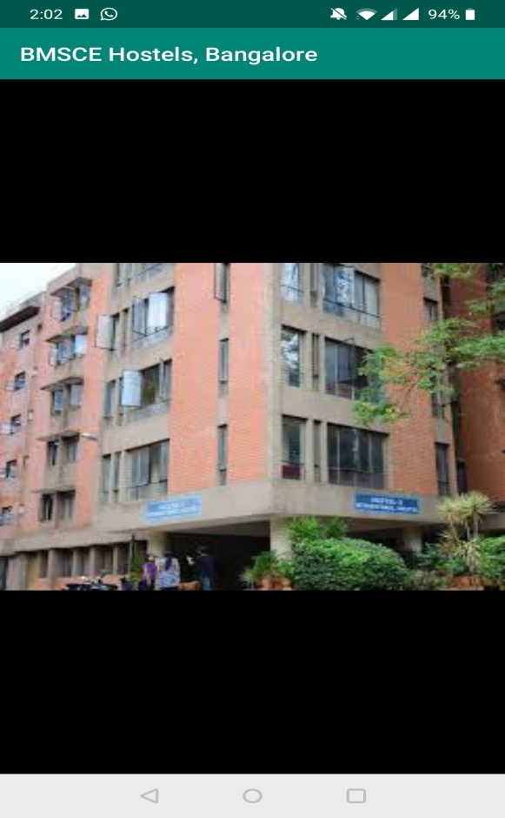

This is a gallery fragment along with xml file which contains various images of hostel. This also contains images of outside hostel and as well as hostel rooms. And in the same way mess image also. Student can scroll up and down in the page to see various images. If they want they can click on the image and few in it large mode. When they click on each image corresponding fragment for the image is used to display image in large mode.

**Hostel members and warden**

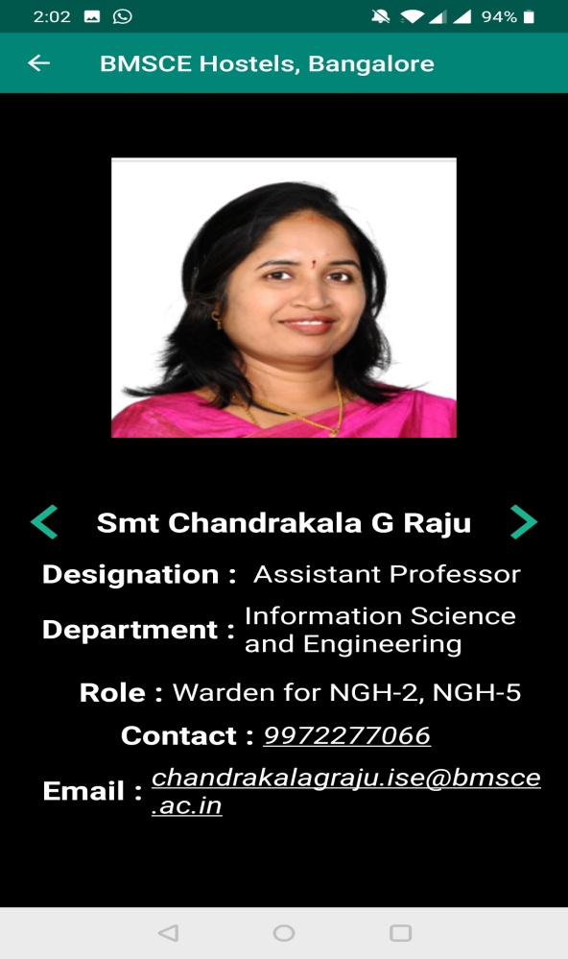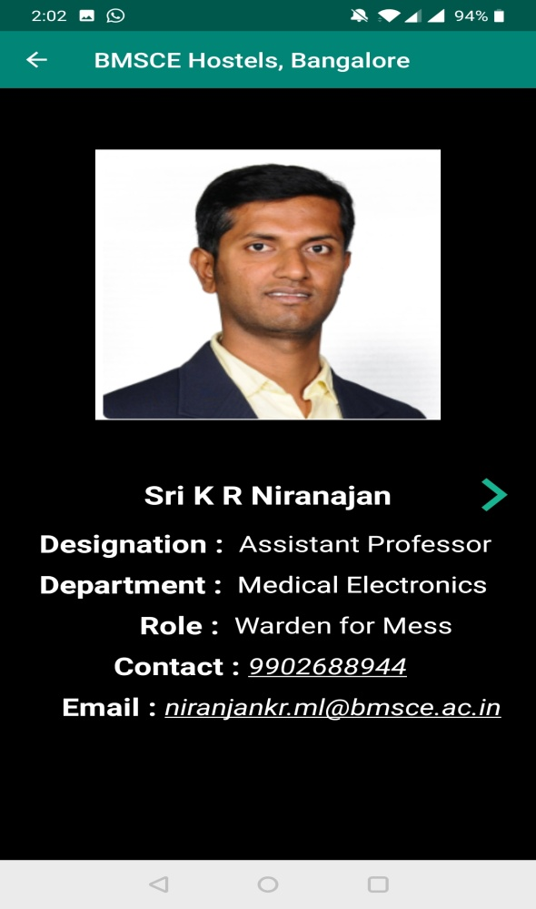

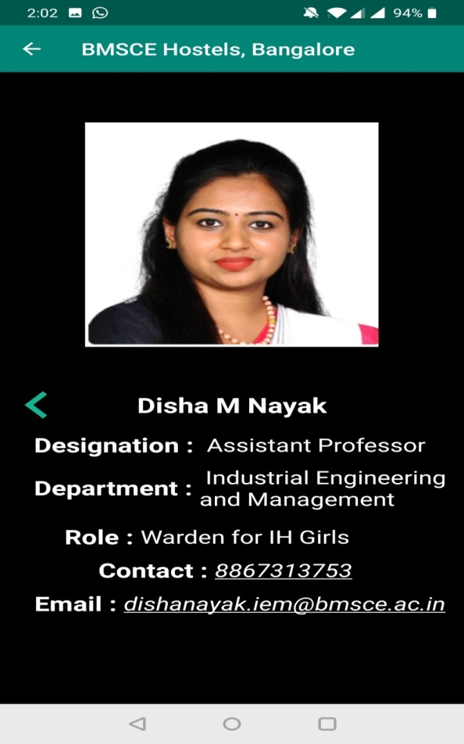

Each hostel has a warden. And student can see the details regarding the hostel wardens. The fragment displays the details of warden that is their photo, department detail, designation, hostel for which they are in charge and along with that their phone number and email id. Student can use that to contact the warden for any hep and suggestions. There are many fragments which are involved in this to display the details of the warden and the hostel members.

**Hostel Mess Menu**

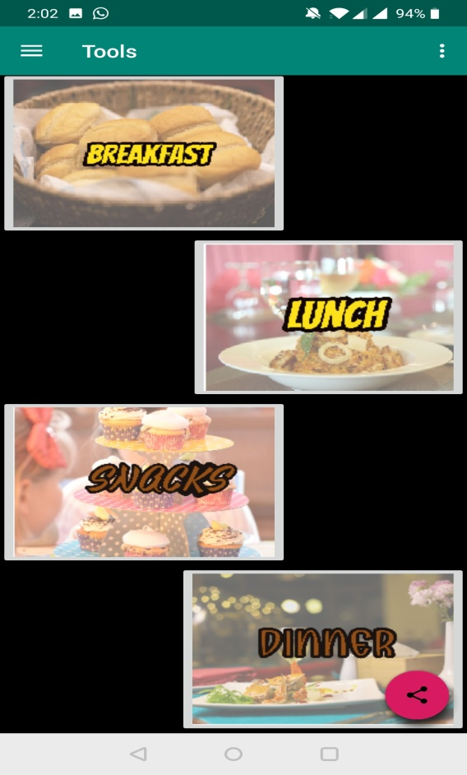 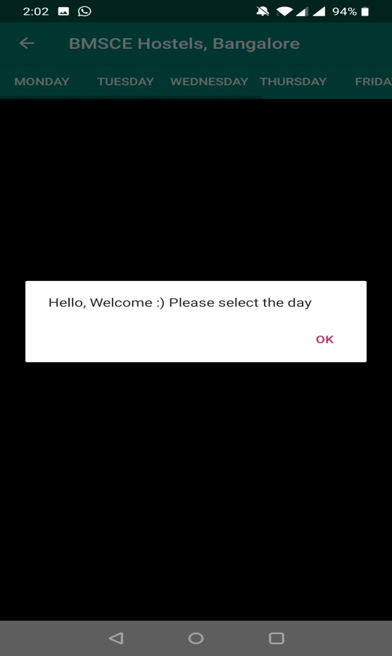

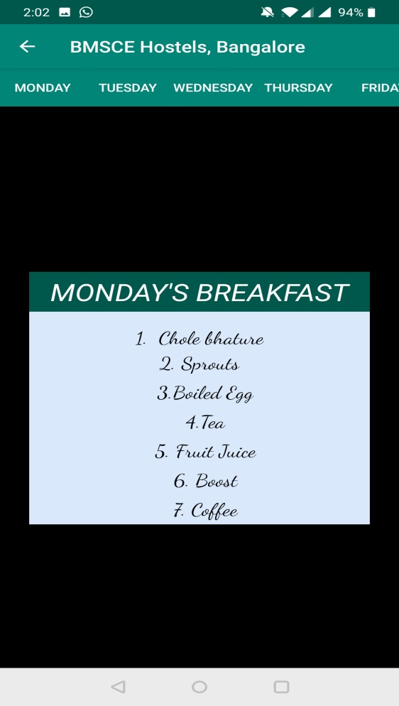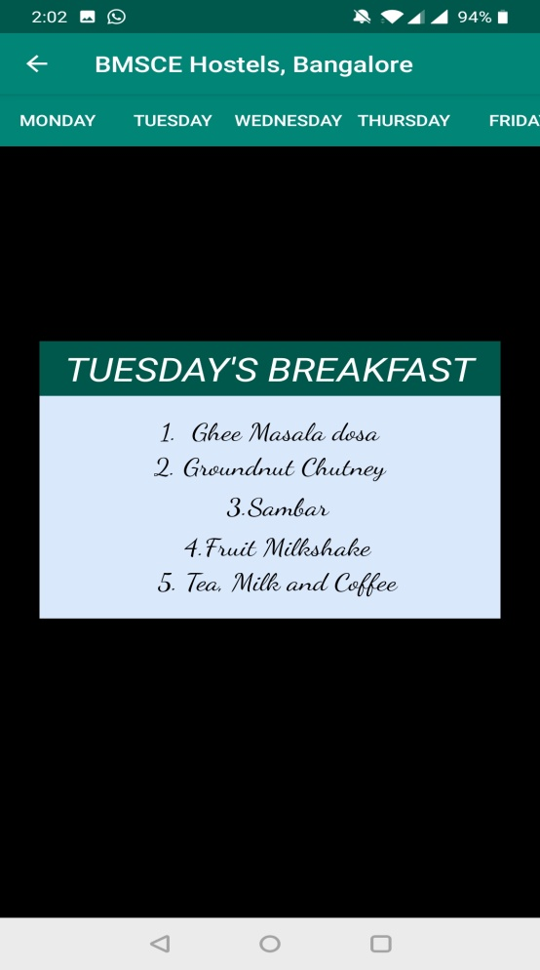

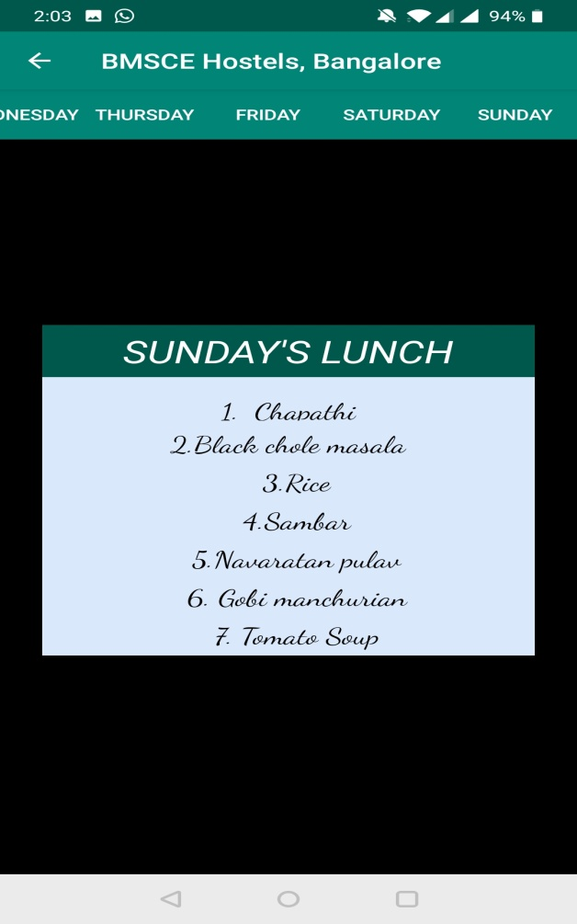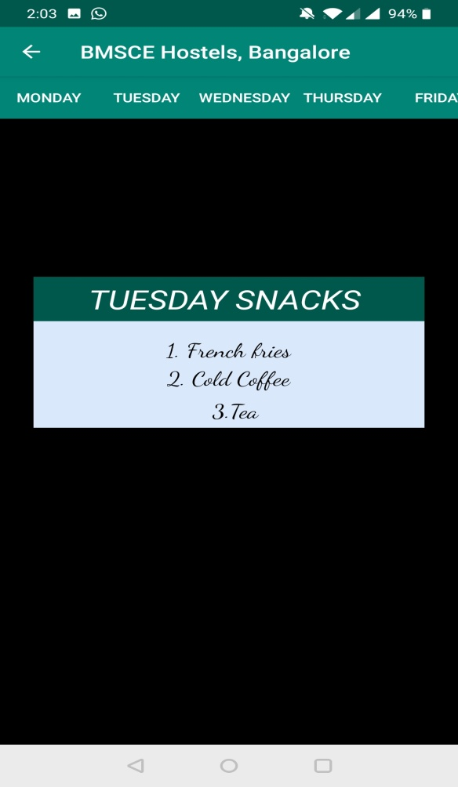

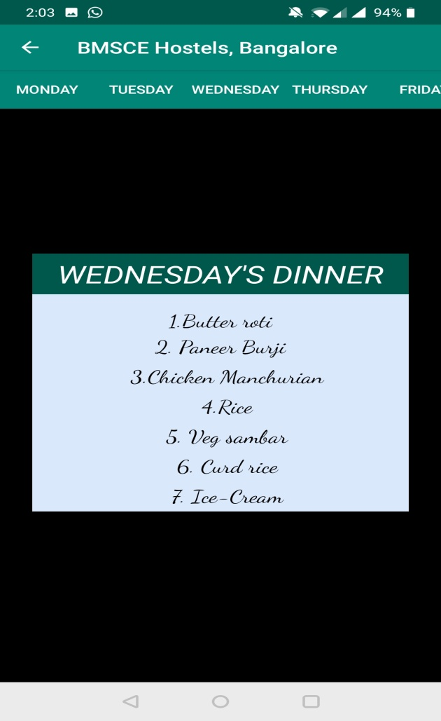

Hostel menu is the very important thing in the hostel management. BMSCE hostels allow students to decide the menu for each month .Students can sit the mess warden and decide menu for entire week. This menu is also included in the app. When you click on the menu option a fragment with 4 buttons is displayed, which includes buttons for breakfast, lunch, snacks and dinner. User can click on the buttons to see corresponding menu.

When you click on any option you will get a fragment which allows you to select the days of a week. They can click any option and the corresponding details of that day will be displayed using fragments in the page.

User can click and see all day complete food options. This will be a very helpful feature .With a button click student can see the complete day menu.

**Location**

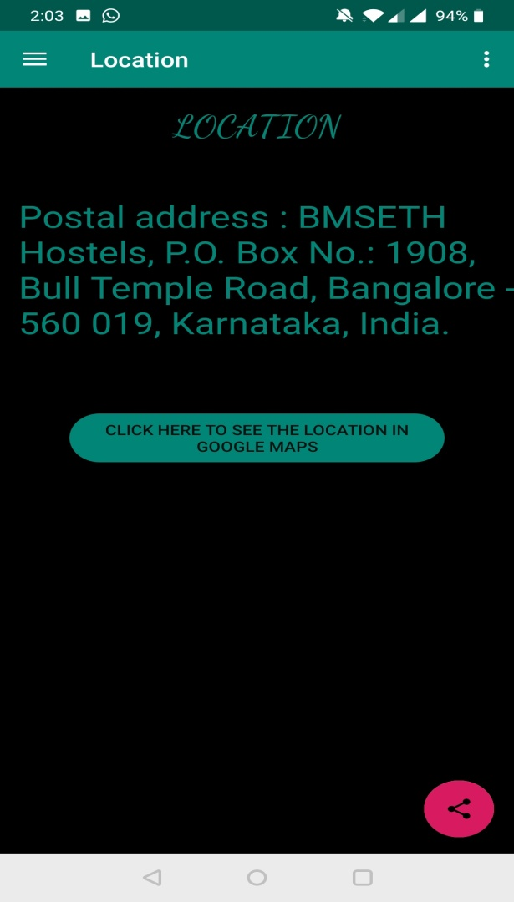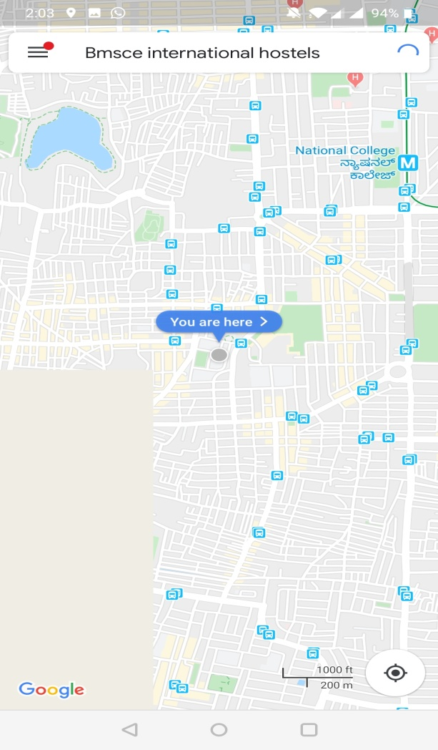

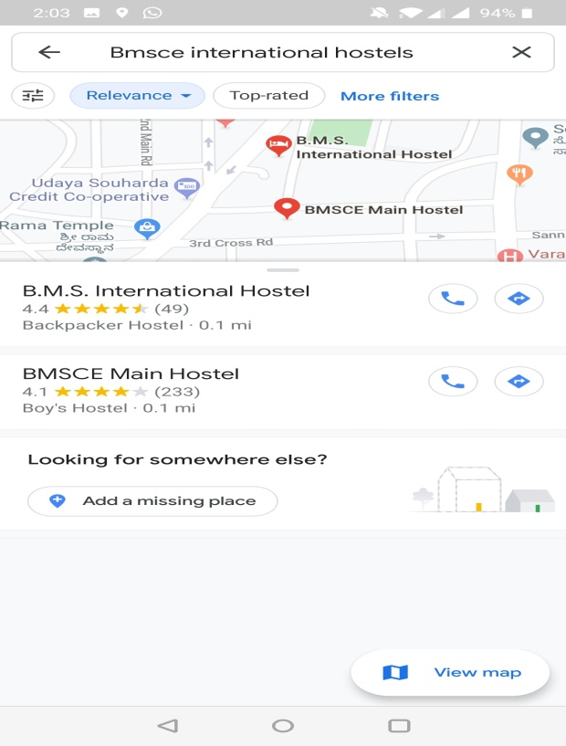

It’s also very important for the students to know the correct location of the corresponding hostel. There is a option to see the location of hostel. When user clicks on that he will get a normal display fragment which tells the address of hostel.

There is button also there to see the location of hostel; in the Google map. Map APIs are used for this purpose. When you click on the see location button then Google map is used and that will open and the various locations of hostels are displayed.

User can click on any location and get directions about the app.

**Contact Us**

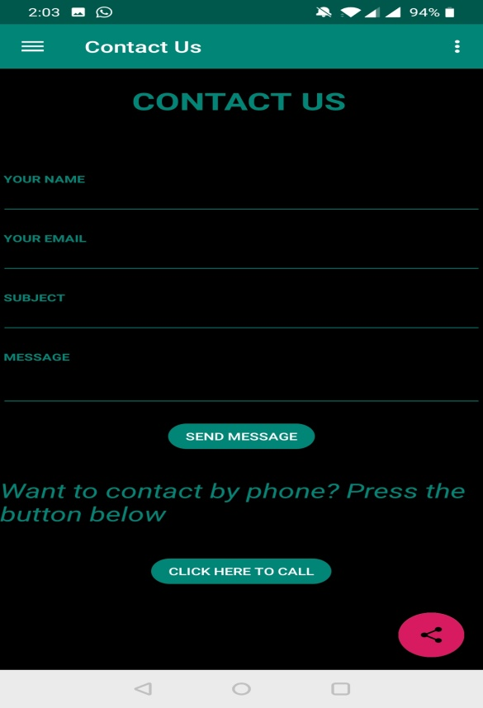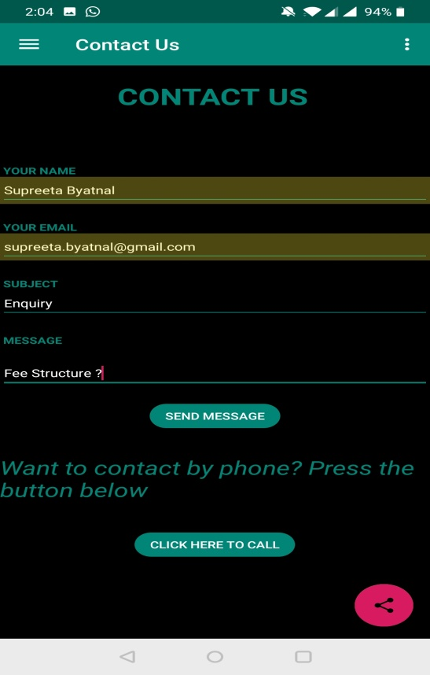

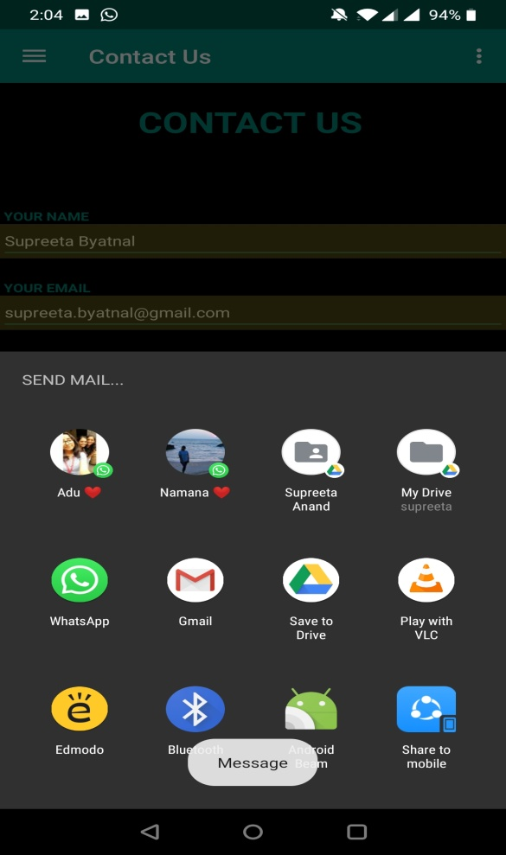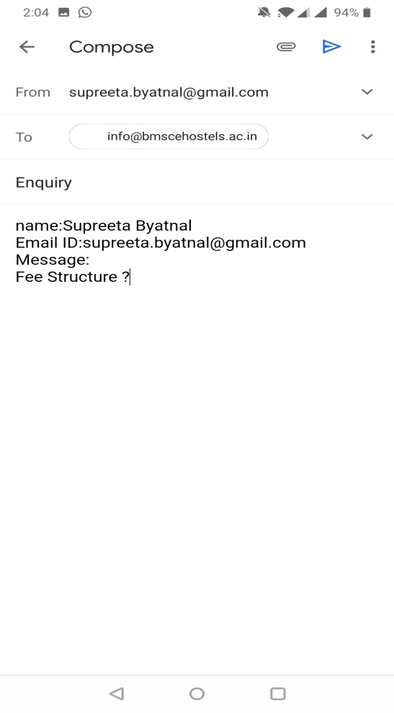

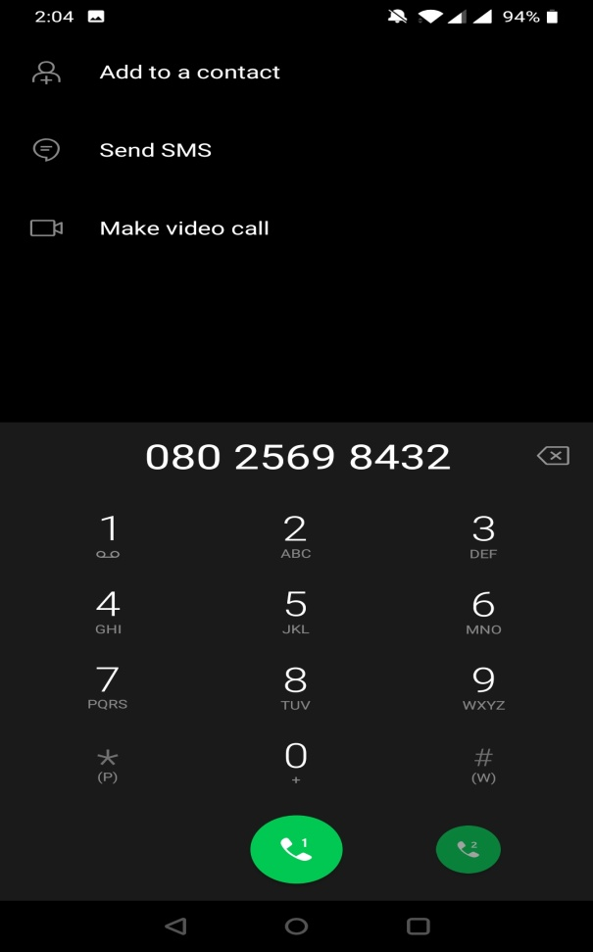

There is a option to contact us. This option basically helps the app user to contact hostel office if they have any queries. They have basically 2 ways to contact one through call or other through email.

When you click on contact us a form fragment will be opened which ask you enter your details and any queries that you have. Then you can select the send message button and a mail activity will open there u can send the mail to corresponding person.

Or user can click on call button to directly call the hostel office for their queries .When they click on call button a call activity will be displayed.

**Rules and Regulations**

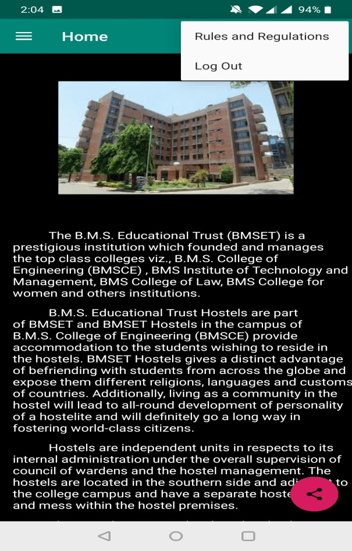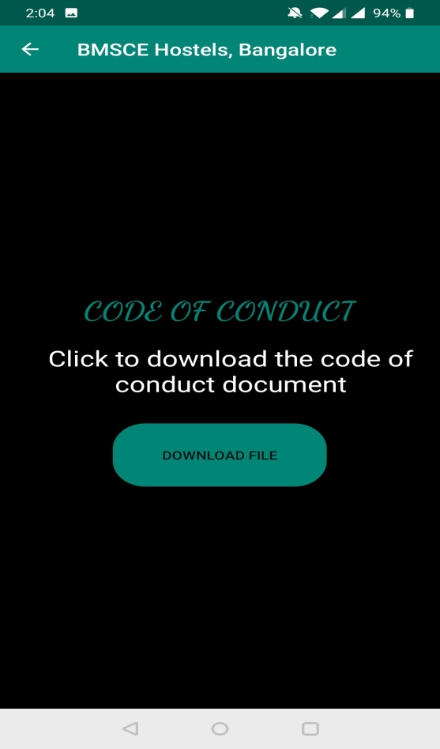

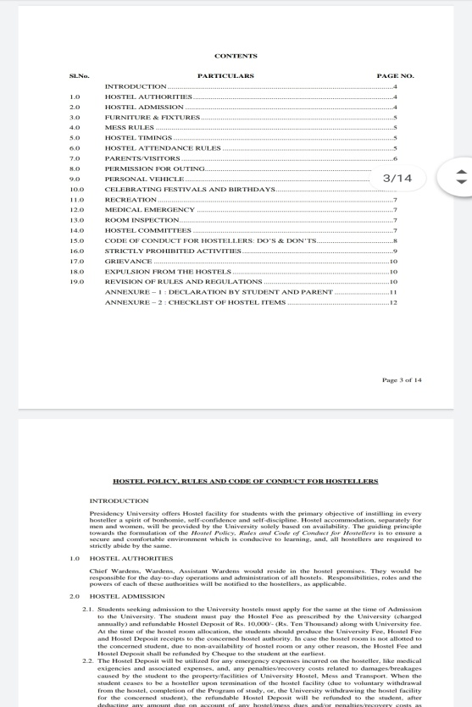

Students can access the hostel rules and regulations using the button which is in home screen. By clicking on that the page with details is open along with a button. By clicking on the button the rules and regulation manual of hostel will be downloaded .Student can open that and view it for any further clarification.

This manual will be downloaded in the devices memory and any time if student want can open an access it.

**App Detail Sharing**

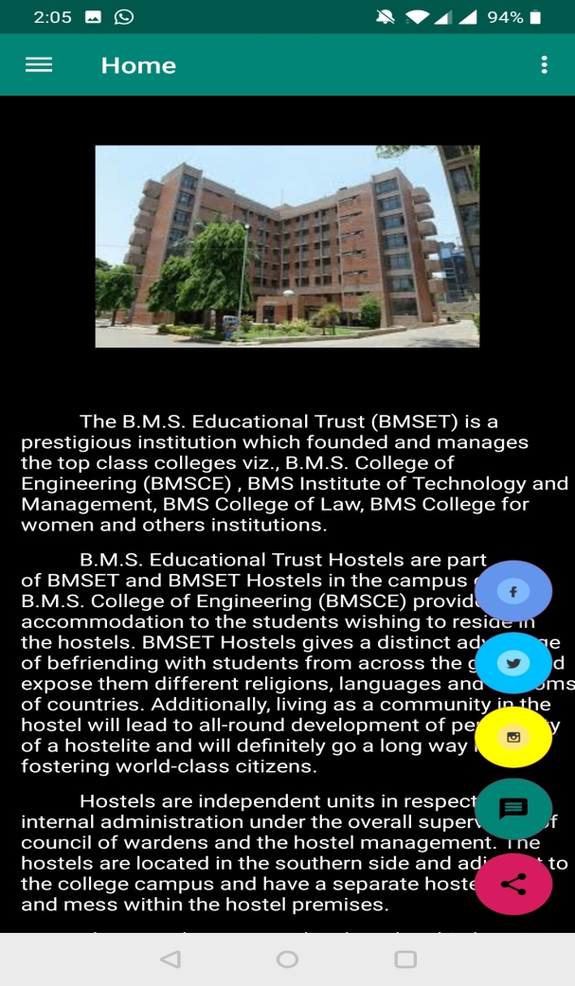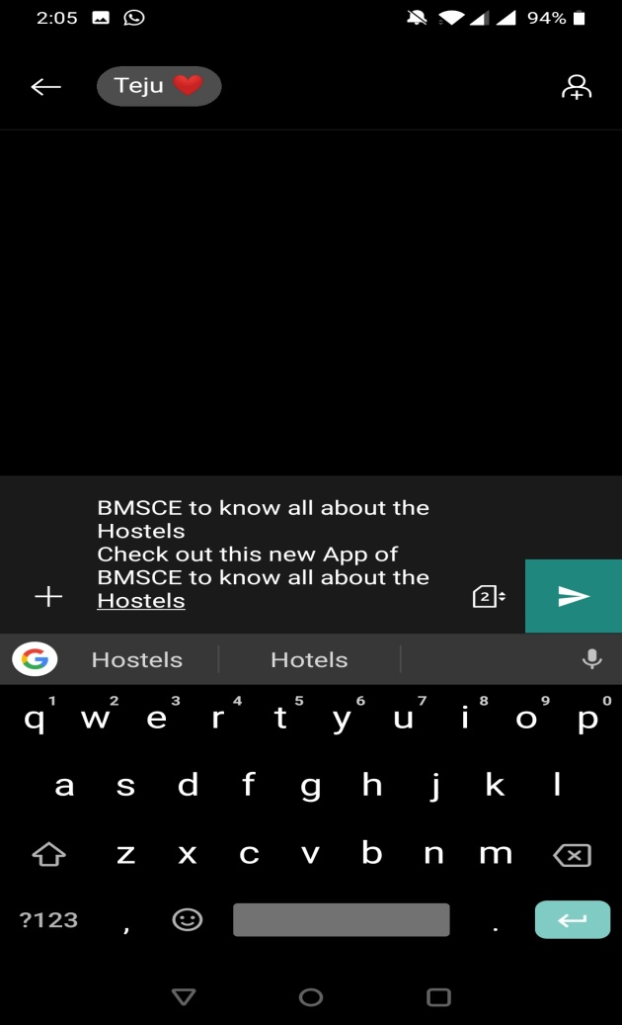

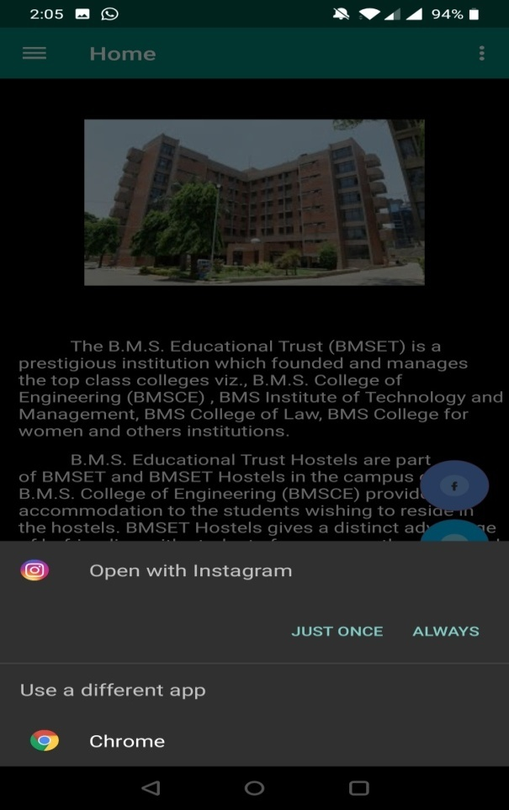

This app also allows the user can share the app link to download the app to other. Various options are there to share the app link that can through normal message or instagram.

If the user clicks on the message button then normal message option will be opened and user can add recipient and then send the message.

User can also share details regarding app using instagram. By clicking on the instagram icon and the corresponding activity for that button will be opened.

There are various options are also available.

**CONCLUSION**

HOSTEL MANAGEMENT APP is very useful for hostel enquiry and mess menu system. This hostel management app is designed for people who want to manage various activities in the hostel. For the past few years the numbers of educational institutions are increasing rapidly. Thereby the numbers of hostels are also increasing for the accommodation of the students studying in this institution. And hence there is a lot of strain on the person who are running the hostel and software’s are not usually used in this context.

This particular project deals with the problems on managing a hostel and avoids the problems which occur when carried manually.

**REFERENCES**

* <http://bmsce.ac.in/home/About-BMSET-Hostels>
* <https://www.androhub.com/android-download-files-save/>
* <https://abhiandroid.com/database/sqlite>
* <https://www.journaldev.com/12648/navigationview-android>
* <https://ptyagicodecamp.github.io/creating-sub-menuitems-for-fab-floating-action-button.html>

* <https://proandroiddev.com/creating-an-expandable-floating-action-button-in-android-6626b968559e>
* <http://zacktutorials.blogspot.com/2014/07/android-downloading-and-viewing-pdf.html>
* <https://stackoverflow.com/questions/36579799/android-switch-actionbar-back-button-to-navigation-button>